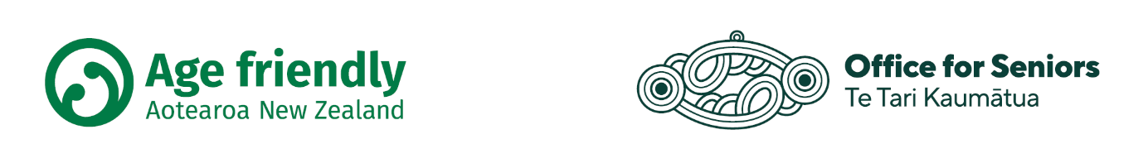

**Age friendly Aotearoa New Zealand Network application form**

The Office for Seniors provides a range of support and advice to organisations interested in developing age friendly communities. The Age friendly Aotearoa Network has been set up as a community of practice for organisations that are leading Age friendly strategies or plans with their communities.

Before completing this form, please read the Age friendly Aotearoa New Zealand Network Terms of Reference and ensure that you understand the eligibility criteria and expectations of membership.

If you have any questions about this form or about the Network, please email: [agefriendlyfund@msd.govt.nz](mailto:agefriendlyfund@msd.govt.nz)

**Applicant details**

|  |  |
| --- | --- |
| **Name of organisation** |  |
| An organisation can have up to two people representing the organisation at Network meetings. Please complete their details below. Ideally at least one of these people is from the city/district council. | |
| **Primary local lead**  **(key contact person)** |  |
| Role/organisation |  |
| Email address |  |
| Phone number |  |
| **Second nominated local lead** |  |
| Role/organisation |  |
| Email address |  |
| Phone number |  |

**Your community**

|  |  |
| --- | --- |
| Tell us about your city, town, or community | |
| Location (district or city name) |  |
| Population details | What number and percentage of your population are older people 65+ years?  If you know what that population number and percentage is projected to be, please include details. |
| Age friendly plan | If you have a plan, please provide a website link. (This will be added to the Office for Seniors Network website page.) |

**Your Age friendly work**

**What commitment has your organisation made to supporting the development of an Age friendly strategy or plan for your community?**

* Please provide information that demonstrates this commitment such as signed memos/briefings or meeting minutes
* If your organisation is not a local council, please also provide a letter of support from your local council that demonstrates its ongoing commitment to your organisation’s work.

|  |
| --- |
|  |

**Briefly describe the Age friendly work that your organisation already has underway with your community**

* Have you done a baseline assessment/needs assessment? Y/N   
  If so, please provide a website link
* Have you completed a strategy/plan? Y/N   
  If so, please provide a website link
* Have you measured/evaluated the success of your plan? Y/N   
  If so, please provide a website link

|  |
| --- |
|  |

**Your needs, ideas, and goals for the Network**

**What do you want to get out of being involved in the Network?**

* Please describe how you think membership of the Network will support the work of your organisation. Is there a specific area of age friendly that you require assistance with?

|  |
| --- |
|  |

**Next steps**

Please send this completed form to [agefriendlyfund@msd.govt.nz](mailto:agefriendlyfund@msd.govt.nz)